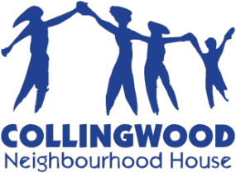

5288 Joyce Street, Vancouver, BC V5R 6C9

Phone: 604 435-0323 Fax: 604 451-1191 Website: www.cnh.bc.ca

Volunteer Posting

Volunteer Position: | Neighbourhood Connector
Posting End Date: | Ongoing
Name of Program: | You Count, Community Development
Program Description: | Collingwood Neighbourhood House (CNH) is looking for a volunteer who lives in Renfrew-Collingwood to build social connections and relationships with neighbours in their own immediate place of living -a neighbourhood block or apartment floor. The volunteer would be supported by a staff person to develop a project plan, communicate with neighbours, develop surveys to find out what neighbours are interested in, and work with neighbours to plan community activities such as movie nights or block parties. This position is for a total of 20-40 hours.
Day and Time: | Evenings and Weekends.
Location: | Collingwood Neighbourhood House and your own residential block or apartment.
Duties: | Duties include knocking on neighbours’ doors, surveying neighbours and helping to plan events for your neighbours.
Requirements: | Volunteers must be 16 years old or older and must live in the neighbourhood of Renfrew-Collingwood.
Benefits: | The volunteer get to know their neighbours better, learn about community organizing and will be supported by staff to work with their neighbours to make their ideas come alive in their community. A reference letter can be provided upon request.

If you are interested in volunteering, please submit your completed registration form to Irene Mella, Office and Volunteer Coordinator (email: imella@cnh.bc.ca, tel: 604-435-0323 ext 246).

